

Ilam Electricity Distribution Company

Feasibility Study Summary Report
70 MW Jalizi Solar Power Plant

Ilam Province , Dehloran County, Jalizi Region

Ilam Electricity Distribution Company
Office of Planningand Budget

September 2026

1 . Summary
The present project includes the construction of a solar photovoltaic power plant with a nominal capacity of 70 MW of peak on lands about 100 hectares of Jalizi area of Dehloran city in Ilam province. According to the PVsyst simulation report, the annual energy injectable to the grid is estimated to be about 123.03 GWh and the power plant's performance ratio is 84.59%.
Quantity | Index
70 MW | Power plant capacity
100 hectares | Land Area
kWh/year 123,000,000 | Annual Energy Generated
€21 million | Declaring Investment
2.8 years | Nominal return period

2 - Introduction and specifications of the place of implementation of the project
The location of the project is located in the Jalizi area, Dehloran city, Ilam province. The coordinates of the four points of the land area are listed in the investment worksheet and the required land area is 100 hectares. The method of land transfer is a lease contract with the Land Affairs.

3 - Solar Resources Studies and Basic Design
The arrangement of the solar field is considered as a fixed surface with an inclination angle of 32 degrees and an azimuth of 0 degrees in the simulation.
Quantity | Parameter
kWh /m² 1860 | Annual Horizontal Radiation
837.48 kWh/m² | Horizontal Radiation
26.28°C | Average annual temperature
2077.7 kWh/m² | Radiation on the surface of the array
kWh/m² ۲۰۴۰.۵ | Effective radiation after reforms
32° / 0° | Slope / Azimuth

4. Main equipment of the power plant
Based on the simulation, the PV field consists of 116,670 JinkoSolar JKM-600N-78HL4-BDV modules with a peak power of 600 watts. The arrangement consists of 7,778 strands of 15 modules. The rated power of DC is equal to 70 MW of peak and the surface area of the modules is about 326,129 square meters.
The energy conversion section consists of 24 SMA Sunny Central 2200 inverters with a rated power of 2,200 kW AC per unit. The total power of the AC is 52.8 MW and the ratio of DC to AC is about 1.33. The working voltage range of the inverters in the PVsyst model is 570 to 950 volts.
This equipment is only for preliminary studies and the final equipment is determined after the detailed design of the power plant.

5 - Estimation of energy production
The output of PVsyst simulation shows that the annual energy injected into the grid is 123,032,094 kWh. The specific generation of 1758 kWh per kWh of peak and PR of 84.59% has been achieved.

Injectable Energy (MWh) | Moon
9,256 | January
8,874 | February
9,935 | March
10,704 | April
11,076 | May
11,571 | June
11,386 | July
11,250 | August
11,460 | September
9,764 | October
9,222 | November
8,533 | December
123,032 | Annual Sum

The above annual production is the result of simulation and should not be considered as guaranteed production without examining meteorological data, detailed design, actual losses, network limitations and operating conditions.

6 - Casualty Analysis
According to the PVsyst loss chart, the increase in radiation on the surface of the collectors relative to the horizontal is about 11.7 percent and the IAM loss is about 1.79 percent.
Thermal losses were reported to be 9.47 percent, module and string mismatch losses were reported to be 2.10 percent, and wiring ohio losses were reported to be 1.09 percent.
In the inverter section, the operating losses are 1.73 percent and the losses due to overcoming the rated power are 0.40 percent.
7 - Connection to the grid and electrical infrastructure
Due to the 70 MW capacity of the power plant, the connection to the 132 kV grid is considered through the construction of a dedicated substation of the power plant. The dedicated substation will be responsible for collecting the power output of the power plant, increasing the voltage level, and transferring energy to the grid connection point.
The final specifications of the substation, including the capacity and number of transformers, the connection level, the number and type of 132 kV buses, the busbar arrangement, the length and specifications of the communication line or cable, protection and control equipment, telecommunication and SCADA requirements, power quality, reactive power, and the requirements of the network operator should be determined and approved based on the studies of the connection to the grid and the opinion of the West Regional Electricity Company.
In addition to the main production equipment, the project will require DC and AC collection infrastructure, augmentation transformers, internal grid, ground system, protection and control, telecommunications, measurement, lighting, and safety equipment.

8 - Required Infrastructure
Quantity | Banks
5,000 m³/year | Water
kWh/year ۸۰۰,۰۰۰ | Electricity Consumption
_ | Gas

The above values are in accordance with the investment worksheet and in the executive design, especially for the washing water of the modules, administrative and service uses, they should be reviewed and stabilized based on the operation method and the equipment selected.

9 . Land, Permits and Executive Requirements
The required land has been announced to be 100 hectares and its transfer is predicted through a lease agreement with the Land Department.
The applicant's eligibility from the West Regional Electricity Company, the transfer of land from the land affairs, connection to the grid, and the environment are among the necessary inquiries in this plan.
According to the investment package, the implementation period of the project is predicted to be one year. The realization of this timeline will require the finalization of land, permits, financing, equipment purchase contracts, detailed design, connection studies, and simultaneous implementation of civil and electrical operations.
10 - Sales and Operation Model
is the product of the electric energy plan. The investment package mentions the possibility of selling electricity on the green board of the Energy Exchange, as well as the possibility of concluding a bilateral contract for the sale of electricity with industries and other applicants.
The final sales structure, price, contract period, delivery requirements, and associated risks should be reviewed in the financial model and the final contracts of the project.
The operation of the power plant will require a preventive and corrective maintenance program, online monitoring, periodic washing of modules, control of electrical connections and equipment, maintenance of inverters and transformers, testing of protective equipment, and management of spare parts.

11/ 11/2018 - Investing in Economics and Economics
In the investment package, the value of the required machinery, equipment, and technical know-how is set at 21 million euros, and the total capital required is set at 21 million euros .
The required domestic capital is 52,500 billion Rials and the foreign capital has been declared zero. Also, the return on investment period of 2.8 years has been listed.
Declared Quantity | Economic Indicator
€21 million | Total Investment
52,500 billion Rials | Domestic capital
— | Foreign Capital
2.8 years | Return on Investment Period

12 - Risk Considerations and Supplementary Studies
The main risks of the project include:
- Equipment Supply Risk and Exchange Rate
- Risk of obtaining permits and land transfer
- Risk of Limitation or Network Connection Requirements
- Changes in Electricity Sales Conditions
- Changes in capital and operating costs
- Dust and ambient temperature
- The difference between simulated production and actual production.
Before making a final investment decision, it is recommended to conduct network connectivity studies, detailed design, geotechnical and topographic surveys, water and leaching surveys, environmental assessments, equipment price updates, and the preparation of an independent financial model.

13- Conclusion and Conclusion
Based on the available technical and investment information, the project of constructing a 70 MW Galizi solar power plant is a project that can be considered for investment in terms of production capacity, land location, and the possibility of using solar energy.
The PVsyst simulation shows an annual generation of about 123 GWh and a PR of 84.59%.
From the perspective of the network, the basic solution for connecting the project is to construct a dedicated substation and connect it to the 132 kV network. The technical details of this connection must be determined within the framework of formal grid connection studies by the West Regional Electricity Company, and the capacity or final configuration of the grid equipment cannot be extracted solely from PVsyst information.
Economically, the investment package has announced a return period of 3.5 years. These figures are suitable for initial screening, but for the final investment decision they must be controlled by the independent financial model and the actual data of the electricity sales contract, CAPEX, OPEX, financing, and production drops.

Appendix 1: Map of the Earth
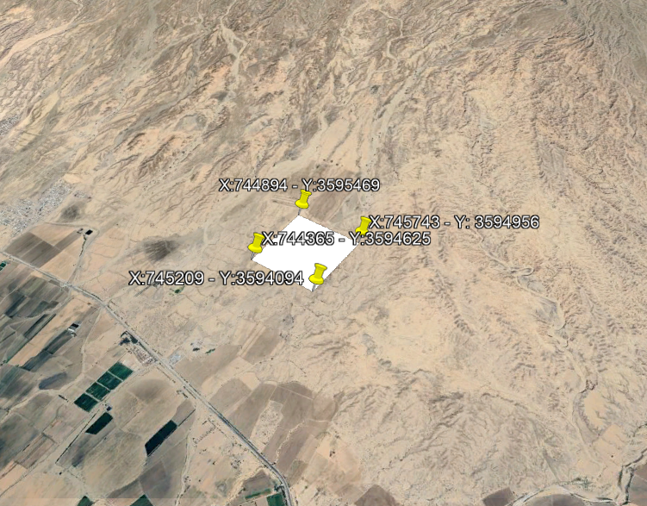

Appendix 2: Report of Project Studies in PVSYST Software 7.3
